

**Computer Science & Engineering**

CSE3501 – Information Security Analysis and Audit

**LAB FAT**

Submitted to **Prof. RAJA SP**

NAME: PUNIT MIDDHA

REG.NO: 19BCE2060

SLOT: L39+L40

DATE: 07/12/2021

Question

Implement the following server configuration using CISCO packet tracer (assign Class C IP address for the end devices)

**a) Firewall configuration**

**b) DNS**

**c) FTP**

**d) SMTP**

**e) HTTP**

Write the aim, and provide necessary screenshots with neat explanations to showcase the procedure followed to build and test the given problem.

Solution

NAME: PUNIT MIDDHA

REGNO: 19BCE2060

LAB FAT

DATE: 07/12/2021

SERVER CONFIGURATION USING CISCO PACKET TRACER

**AIM:**

We have to implement the server configuration using CISCO packet tracer with the constraint that we only have to use C class IP Addresses i.e., 192.0.0.0 to 223.255.255.255 with Default Subnet Mask is 255.255.255.0. We have to implement Firewall Configuration, DNS, FTP, SMTP, HTTP.

**Procedure with Screenshot:**

1. Go to end devices and place 1 Router, 5 servers, 2 PC’s, 2 Switches, 1 Laptop.
2. Now, go to connections and choose Copper-Straight Through cable and connect as in screenshot given below.

* Connect Switch0 with 5 Servers and 1 laptop i.e., Server0, Server1, Server2, Server3, Server4, Laptop0.
* Connect switch0 with router’s FastEthernet0/0, and Switch1 with router’s FastEthernet1/0.
* Connect 2 PC’s with Switch1

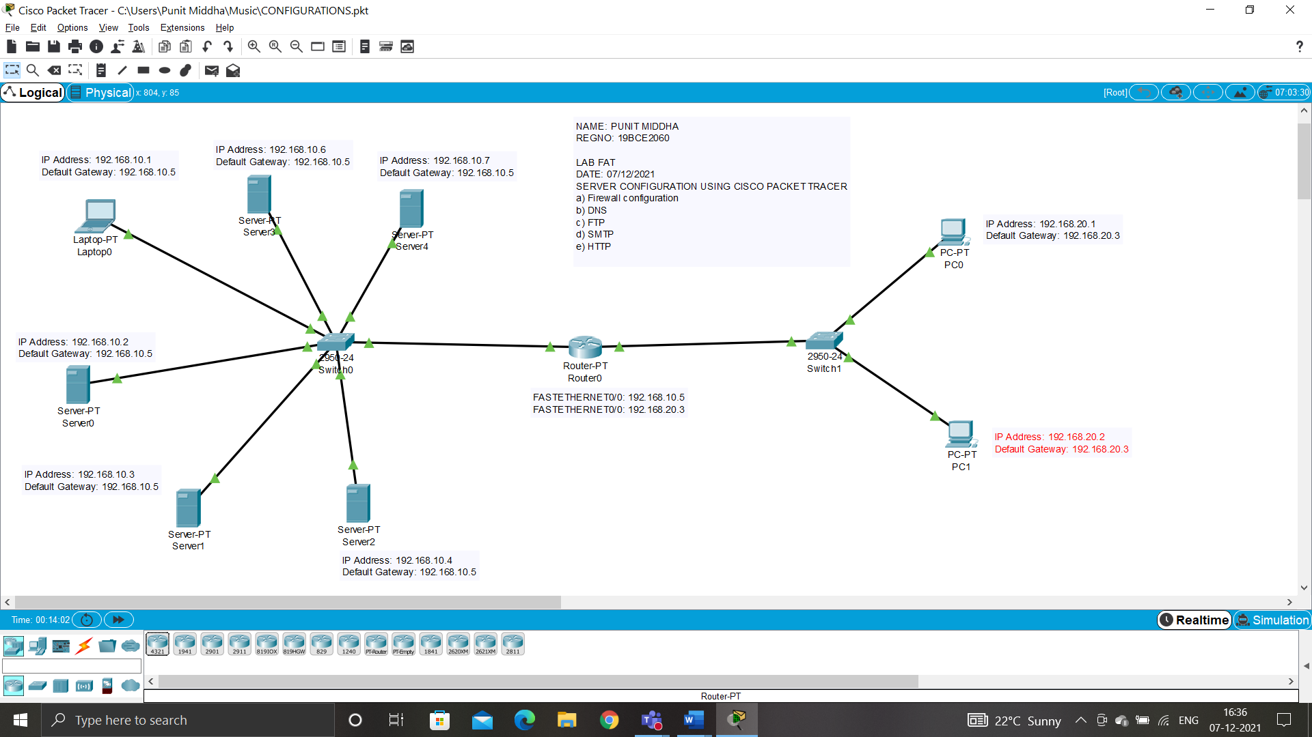

1. After completing the connection procedure, go to **Desktop 🡪 IP Configuration** and set the IP Addresses for each and every end device

* **Server0:**

IP Address: 192.168.10.2

Default Gateway: 192.168.10.5

* **Server1:**

IP Address: 192.168.10.3

Default Gateway: 192.168.10.5

* **Server2:**

IP Address: 192.168.10.4

Default Gateway: 192.168.10.5

* **Server3:**

IP Address: 192.168.10.6

Default Gateway: 192.168.10.5

* **Server4:**

IP Address: 192.168.10.7

Default Gateway: 192.168.10.5

* **Laptop0:**

IP Address: 192.168.10.1

Default Gateway: 192.168.10.5

* **PC0:**

IP Address: 192.168.20.1

Default Gateway: 192.168.20.3

* **PC1:**

IP Address: 192.168.20.2

Default Gateway: 192.168.20.3

All the connections are configured.

1. **Firewall configuration**

IP configuration and Default Gateway of Server4

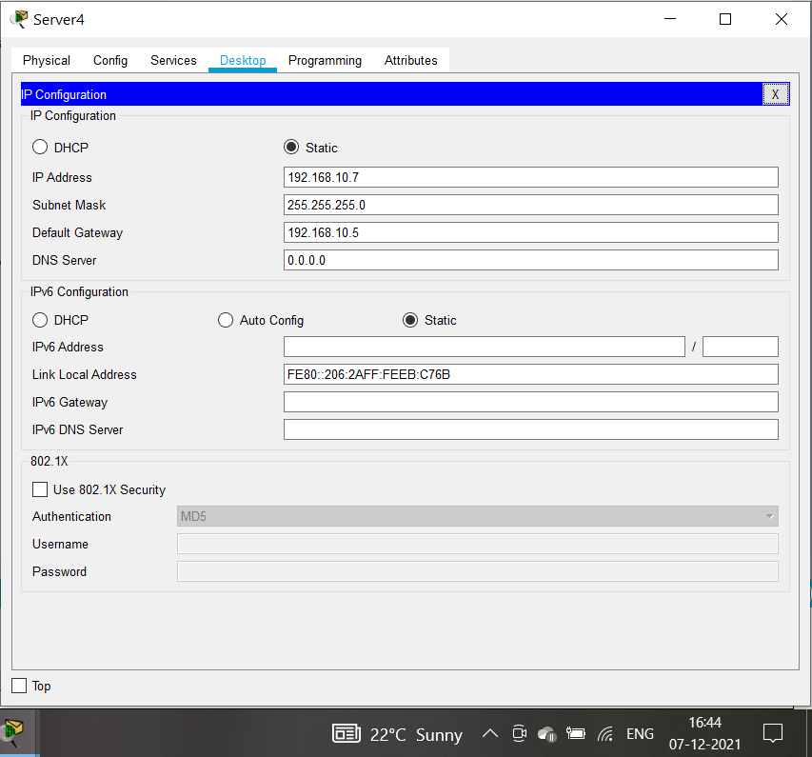

Before Configuring the Firewall, ping the server from Laptop0 i.e., ping 192.168.10.7

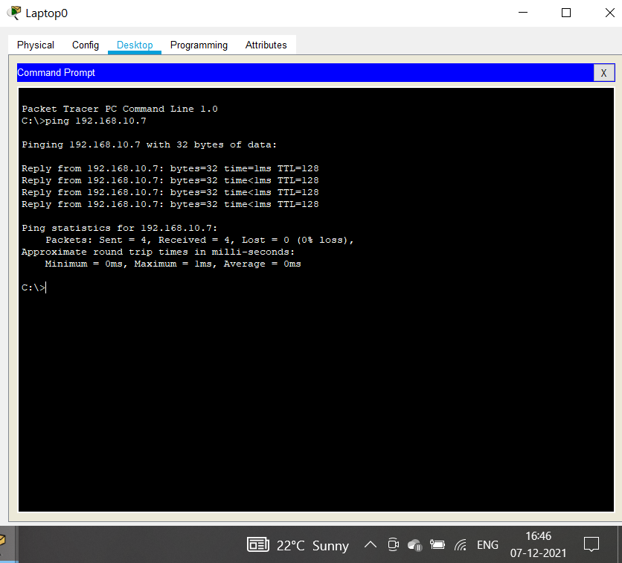

After the Ping command that is executed successfully, now for configuring the Firewall. Go to Server4 🡪 Desktop 🡪 Firewall. Set Action 🡪 Deny, Protocol 🡪 ICMP, remote 🡪 0.0.0.0 and wildcard mask 🡪 255.255.255.255. then ADD and SAVE.

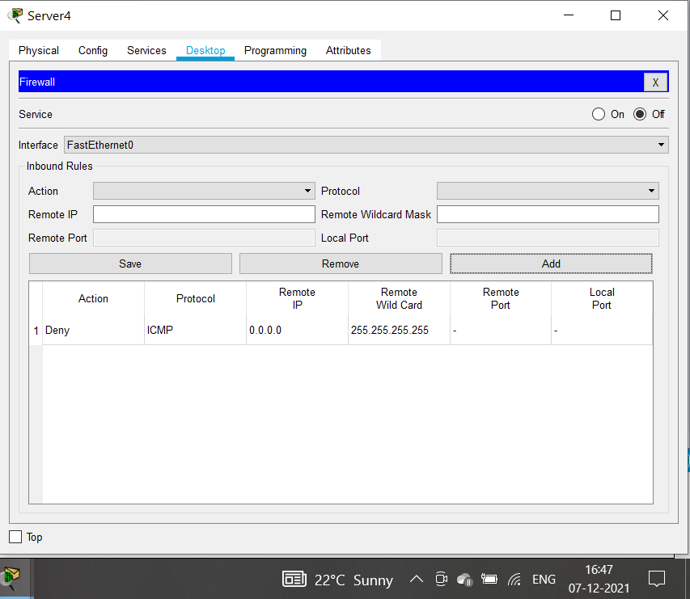

Pinging the Server0 from Laptop0, we can now see that pinging command is not working and hence we can say Firewall configuration is working properly on server4.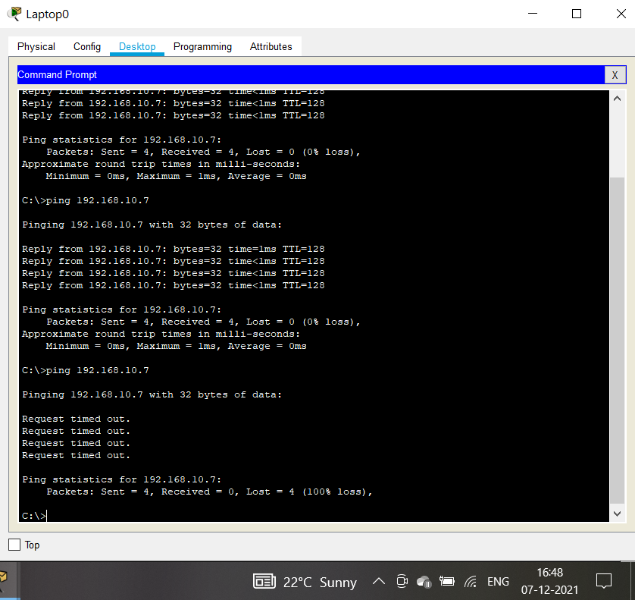

1. **DNS**

Ip config of server1

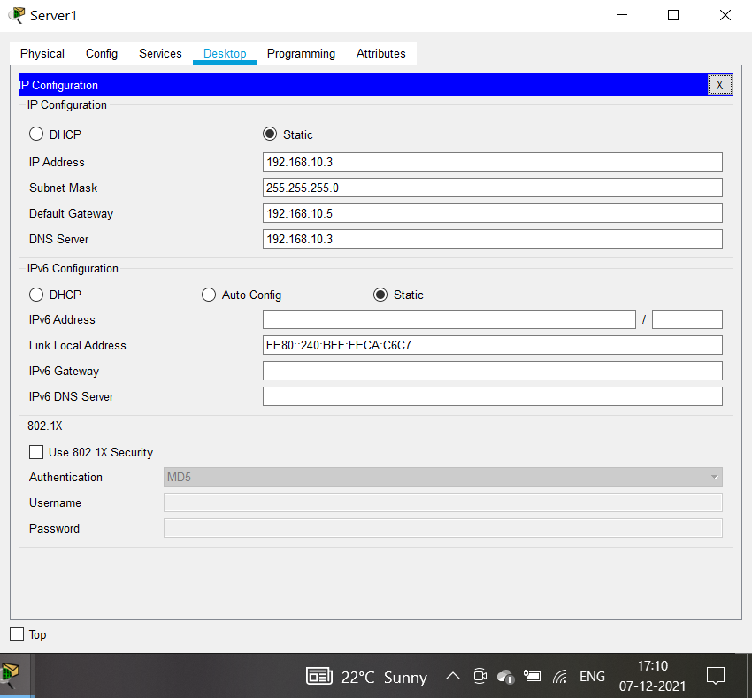

Go to services and add the name type and address

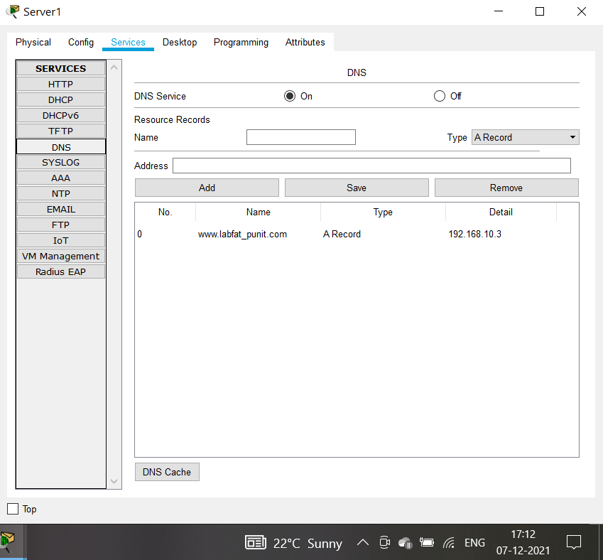

File to access the DNS

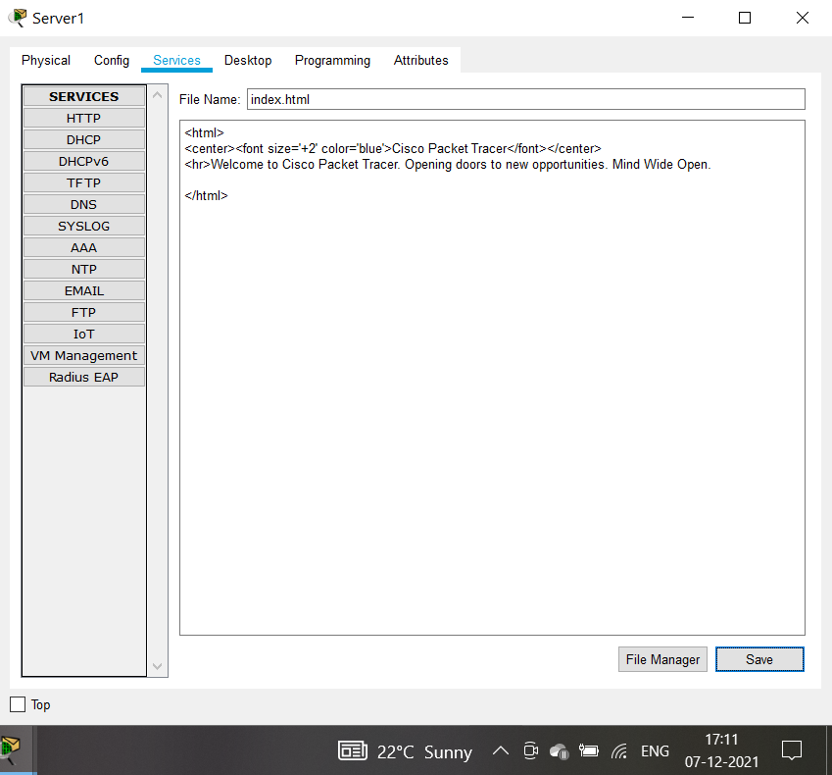

Accessing the file from PC1

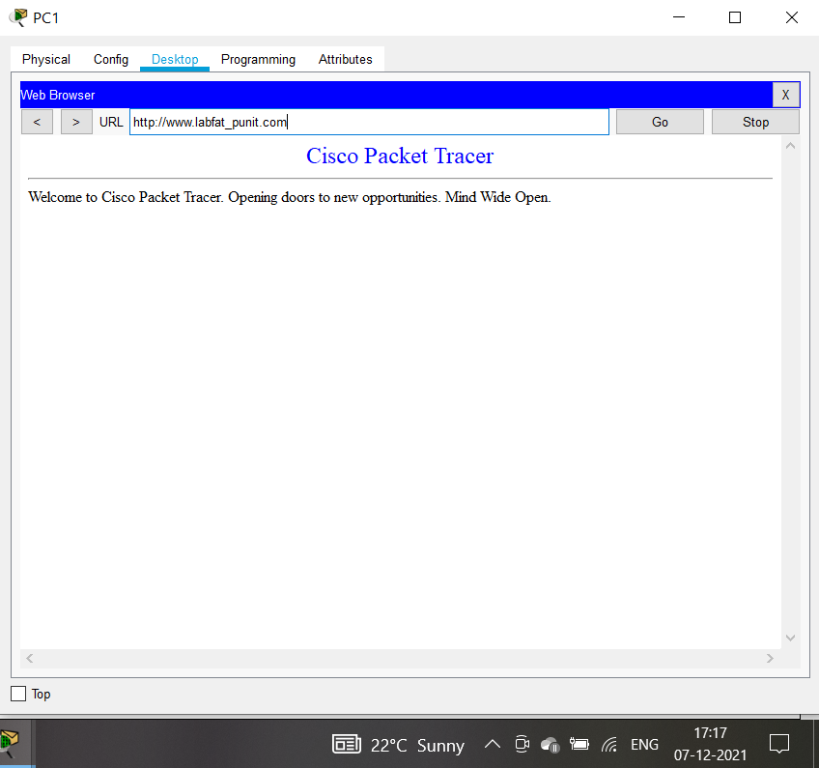

1. **FTP**

Ip Config of server3

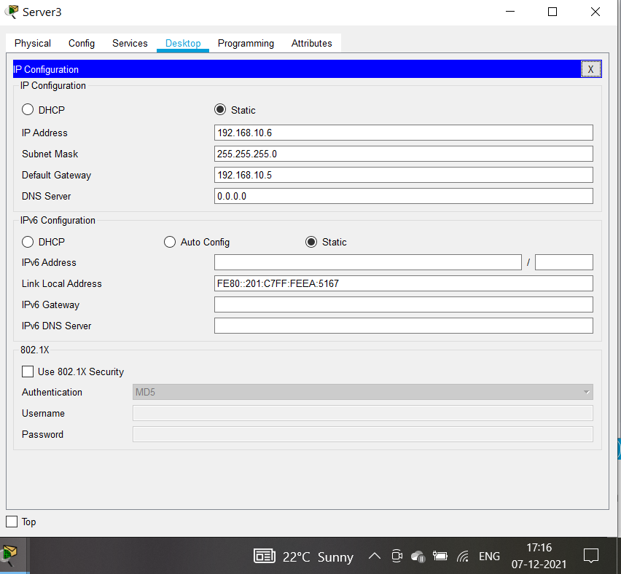

Go to services and on the FTP services give the username and pass with full permission

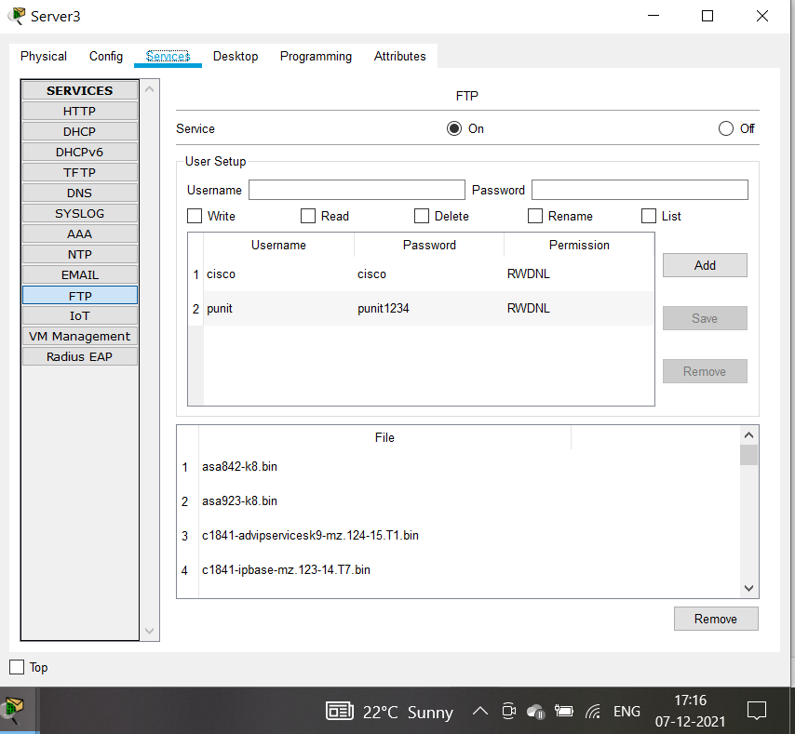

**File that we get from Server named punit_labfat.txt**

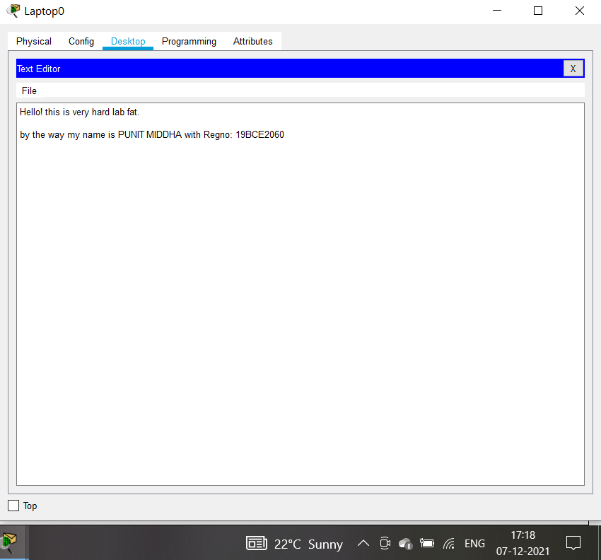

1. **SMTP**

**Ip config of server2**

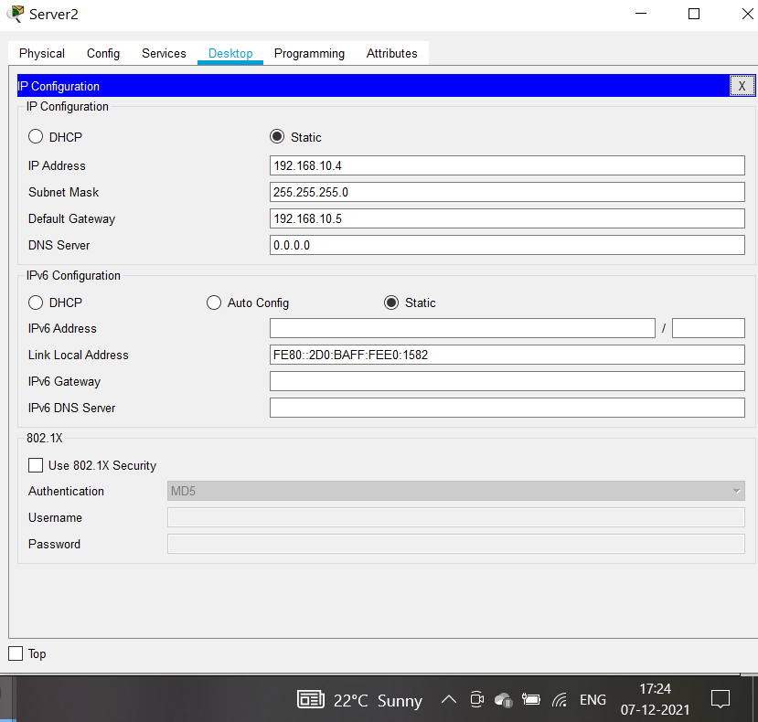

**Go to services and on the email services give domain name username and password**

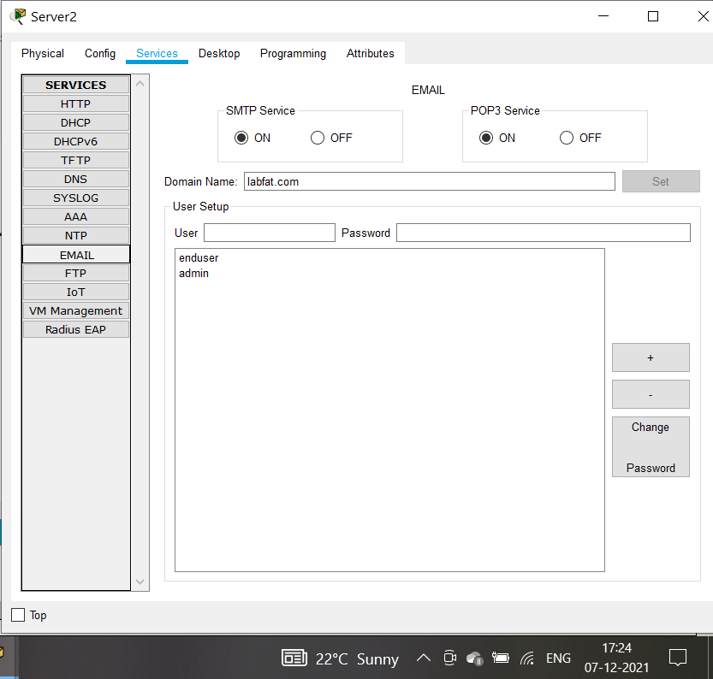

**Configuring the email**

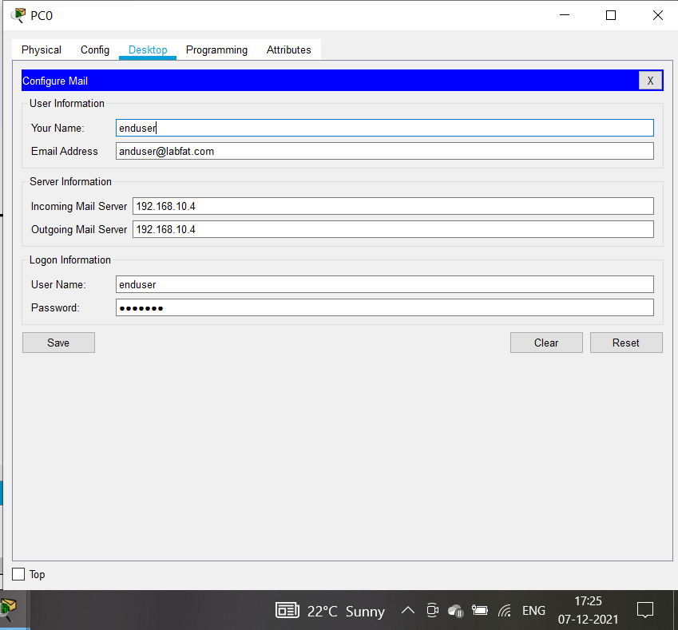

The mail that I have send from admin to enduser

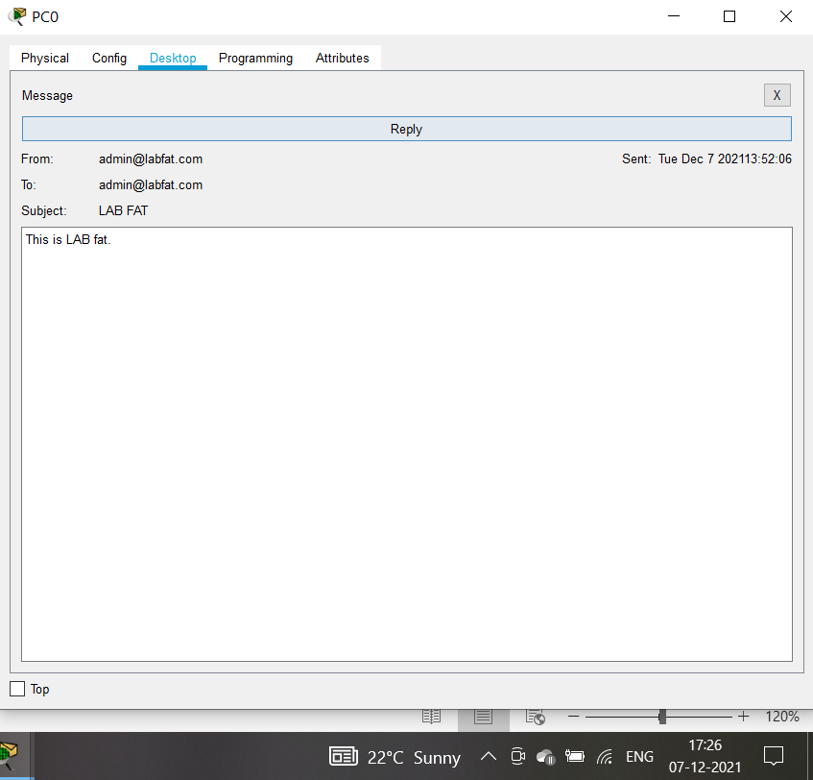

**Received mail to enduser**

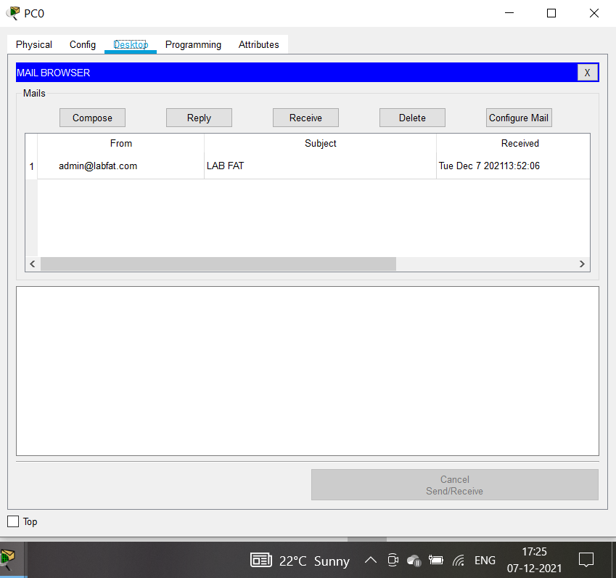

1. **HTTP**

IP configuration of Server0 is given below

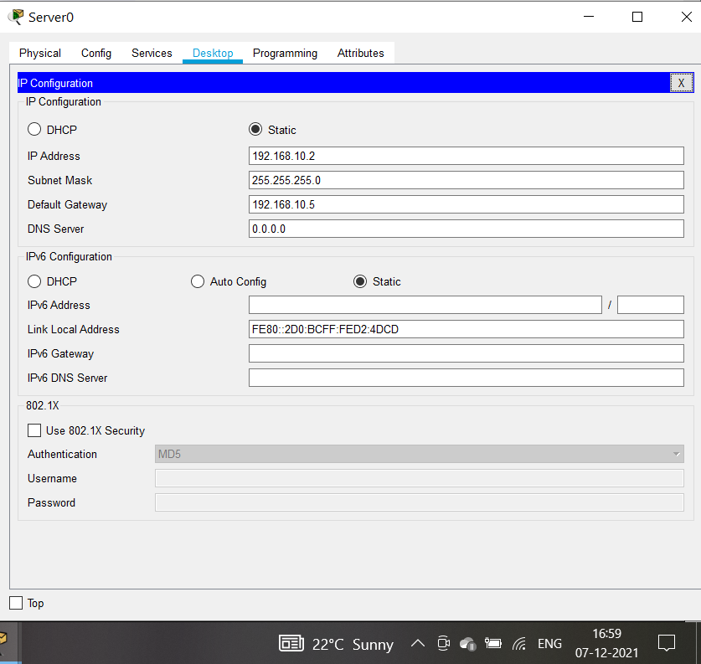

Now, to configure the HTTP, go to Server0 🡪 Services 🡪 HTTP.

Set the HTTP and HTTPS to be “ON”. And change the Index.html file.

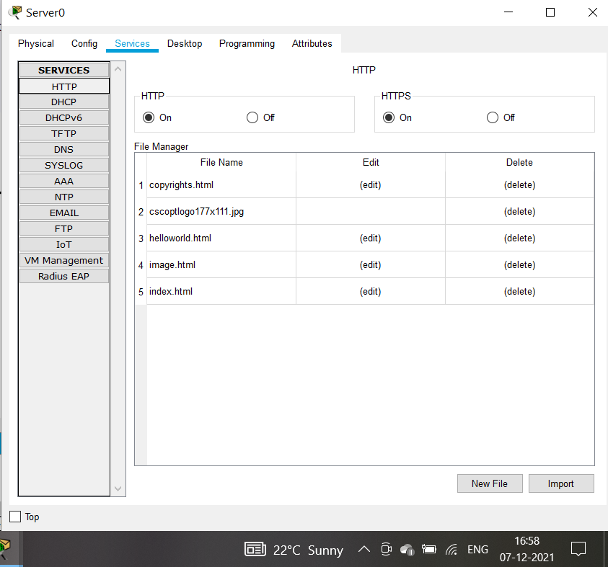

Index.html file is Shown Below

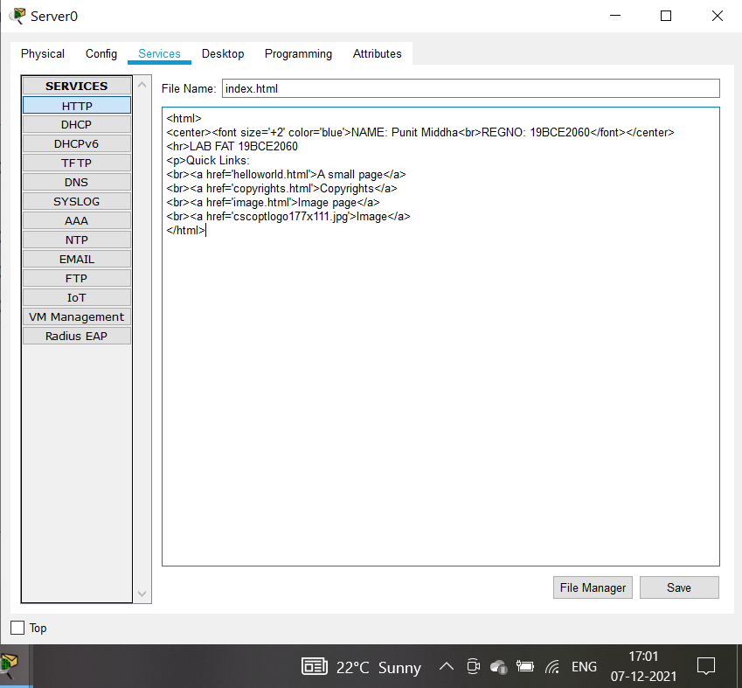

Accessing the Server0 from PC0 using HTTP protocol i.e., http://192.168.10.2

